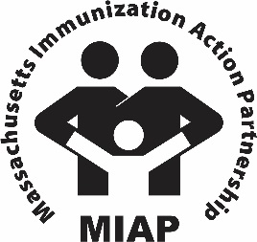

**27th Annual MIAP Conference Award Nomination Form  
Nomination Deadline: Friday, September 2, 2022**

Each year, the Massachusetts Immunization Action Partnership (MIAP) recognizes individuals or groups that have made an outstanding contribution to pediatric immunization in Massachusetts. The recipient of this award is an individual or an organization that has demonstrated particular leadership, initiative, innovation, collaboration and/or advocacy.

The MIAP Conference award will be presented during the 27th Annual MIAP Pediatric Immunization Skills Building Conference. The Conference will be held on October 25, 2022.

To submit a nomination, please complete the information requested below.

|  |
| --- |
| Nominations should be submitted **Friday, September 2, 2022**, to Cynthia McReynolds at the MCAAP Immunization Initiative. (Email: [cmcreynolds@mcaap.org](mailto:cmcreynolds@mcaap.org)). |

**Submission Date:**

**Award Nominee Information**

Name:

Title:

Organization:

Address:

Telephone:

Email:

**Sponsor Information (Nomination Submitted By)**

Name:

Title:

Organization:

Address:

Telephone:

Email:

**Sponsor’s Statement**  *Describe the nominee’s contributions to pediatric immunization, including particular leadership, initiative, innovation, collaboration, advocacy, successes and/or challenges. It will help to provide concrete details and/or examples of activities and indicators of the impact. Specific evaluation data, if relevant, can be helpful too. (Maximum 250 words)*